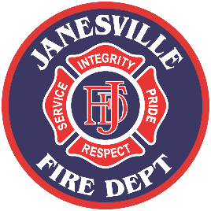

Janesville Fire Department

**FIRE WATCH GUIDELINES**

* Fire watch is required whenever a fire protection system or portion of a system (fire alarm, sprinkler, etc.) is out of service for 4 or more hours. (2012 NFPA 1, 13.1.9 and 13.7.1.4.4)
* If a fire watch is required, notify the Janesville Fire Department:
  + Battalion Chief – 608-373-3440.
  + Leave a message if there is no answer. (This number is checked frequently for messages.)
* Name(s) and phone number(s) for the fire watch personnel shall be provided to the Janesville Fire Department Battalion Chief.
* Fire watch personnel shall be familiar with fire watch procedures, understand the process of evacuating the building and notifying the fire department, and have access to and training in the use of fire extinguishers.
* Fire watch personnel must have a reliable means to contact 911.
* A person assigned to fire watch shall perform NO other work duties.
* Fire watch personnel must actively patrol the area to which they are assigned until the fire protection system is restored and tested.
* A log sheet of walk through times must be kept. Logs shall be signed.
* Fire watch personnel shall check for hazardous conditions including but not limited to:
  + Smoke
  + Fire
  + Electrical arcing
  + Ignition sources (heating equipment/mechanical rooms, school labs, flammable liquids use, etc.)
  + Hot work (grinding, soldering, welding, etc.)
* No smoking or hot work activities shall be allowed while under fire watch.
* Fire Lanes
  + All fire lanes shall be kept open.
  + Fire Department Connection shall be unobstructed.
* All exits shall be available and unobstructed.
* If any hazardous conditions are discovered, fire watch personnel shall immediately:
  + Call 9-1-1 and report the problem
  + Evacuate the building.
* The Janesville Fire Department Battalion Chief shall be notified at 608-373-3440 when the fire protection system is back in service.